Task 1: CGPA CALCULATOR

#include <iostream>
#include <vector>
#include <iomanip>
using namespace std;

int main() {
int n;
cout << "Enter number of courses: ";
cin >> n;

vector<string> grades(n);
vector<int> credits(n);
vector<double> gradePoints(n);

double totalGradePoints = 0;
int totalCredits = 0;

for (int i = 0; i < n; i++) {
cout << "\nCourse " << i + 1 << endl;

cout << "Enter Grade (A, B, C, D, F): ";
cin >> grades[i];

cout << "Enter Credit Hours: ";
cin >> credits[i];

if (grades[i] == "A")
gradePoints[i] = 4.0;
else if (grades[i] == "B")
gradePoints[i] = 3.0;
else if (grades[i] == "C")
gradePoints[i] = 2.0;
else if (grades[i] == "D")
gradePoints[i] = 1.0;
else
gradePoints[i] = 0.0;

totalGradePoints += gradePoints[i] * credits[i];
totalCredits += credits[i];
}

double cgpa = totalGradePoints / totalCredits;

cout << "\n===== RESULT =====\n";
for (int i = 0; i < n; i++) {
cout << "Course " << i + 1
<< " Grade: " << grades[i]
<< " Credit Hours: " << credits[i] << endl;
}

cout << fixed << setprecision(2);
cout << "\nCGPA = " << cgpa << endl;

return 0;
}
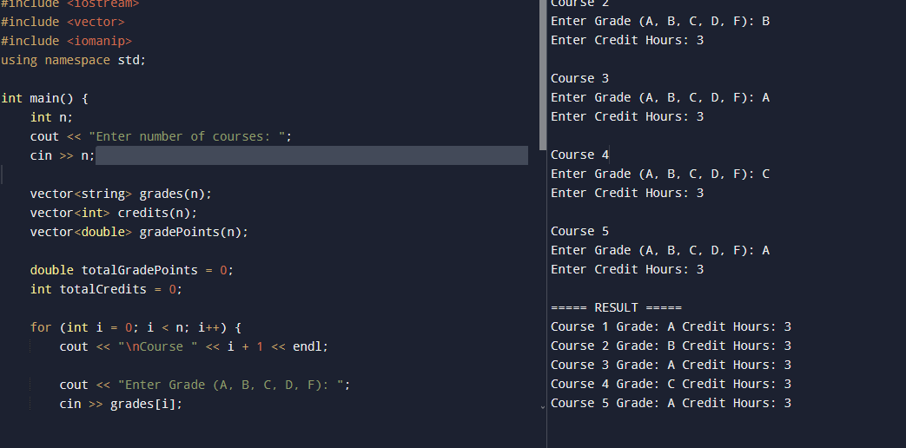

Task 2: Login and Registration System
#include <iostream>
#include <fstream>
#include <string>
using namespace std;

void registerUser() {
string username, password;

cout << "Enter Username: ";
cin >> username;

cout << "Enter Password: ";
cin >> password;

ofstream file(username + ".txt");
file << username << endl;
file << password << endl;
file.close();

cout << "Registration Successful!\n";
}

void loginUser() {
string username, password;
string storedUser, storedPass;

cout << "Enter Username: ";
cin >> username;

cout << "Enter Password: ";
cin >> password;

ifstream file(username + ".txt");

if (!file) {
cout << "User not found!\n";
return;
}

getline(file, storedUser);
getline(file, storedPass);

if (username == storedUser && password == storedPass)
cout << "Login Successful!\n";
else
cout << "Invalid Password!\n";

file.close();
}

int main() {
int choice;

do {
cout << "\n1. Register";
cout << "\n2. Login";
cout << "\n3. Exit";
cout << "\nEnter Choice: ";
cin >> choice;

switch(choice) {
case 1:
registerUser();
break;
case 2:
loginUser();
break;
case 3:
cout << "Goodbye!\n";
break;
default:
cout << "Invalid Choice!\n";
}

} while(choice != 3);

return 0;
}
